# Extended Features

## Modal Dialog

Using the modern <dialog> some javascript, and a polyfill for backward compatibility (made by Google) I made a simple dialog system.

It has two method calls:

### dialogOpen();

This is called from an onclick listener that pulls information from child elements. Used in the news page currently.

CODE

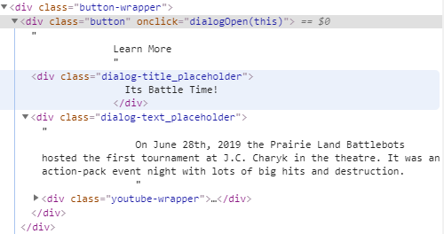

SITE

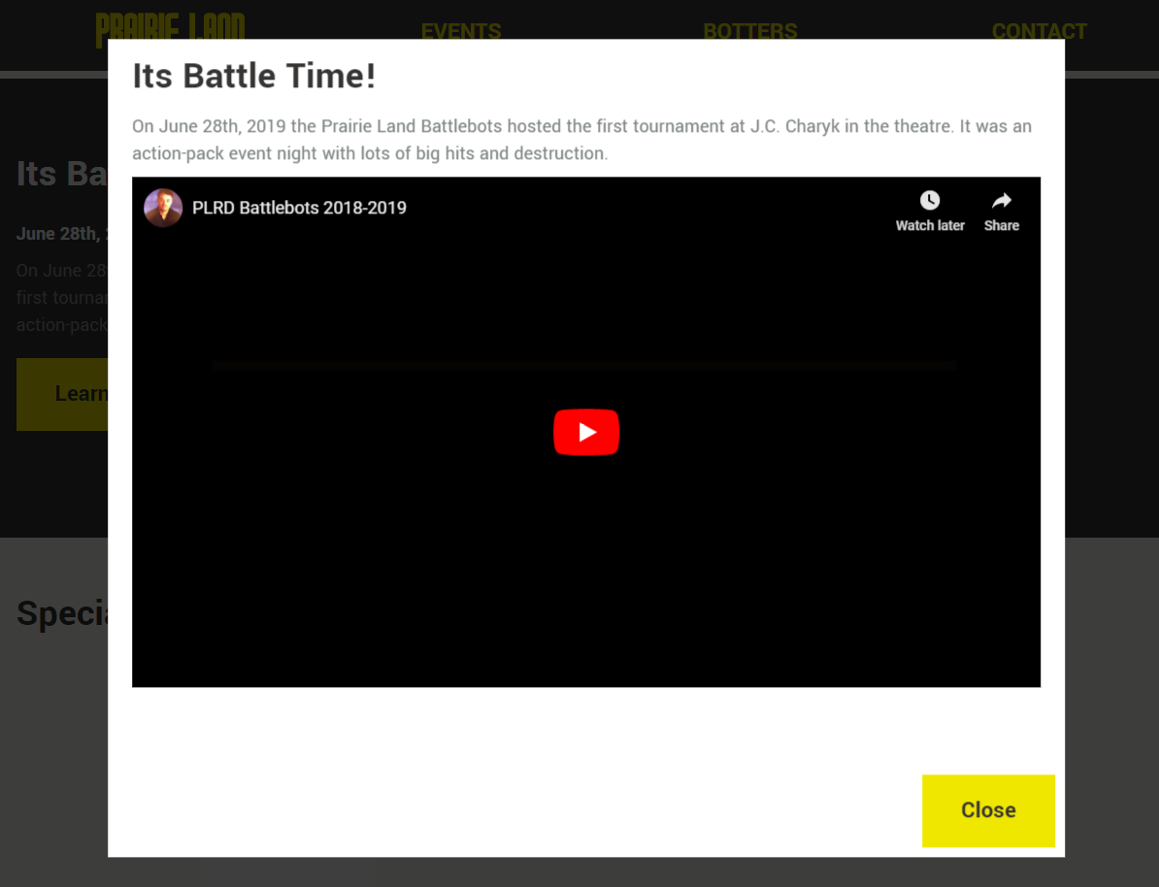

### dialogOpenDoc(title, body);

This takes in two parameters:

* Title = the title of the modal
* Body = the body text of the modal

This method is mostly used by the reference system I setup but could be used to create custom modals using event listeners (or any other method).

CODE

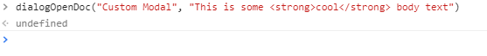

SITE

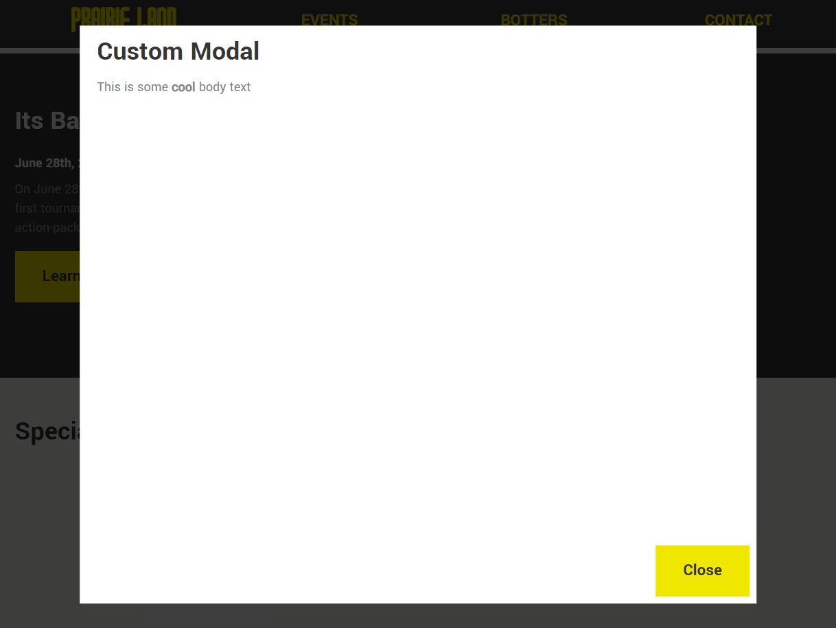

## Loading Animation

The website uses a loader; it loads all elements in the background and removes the loader once completed using JavaScript. The loader is a rotating SVG gear created in Adobe Illustrator and exported as code, and it uses CSS3 animations to rotate and spin out when completed. If JavaScript is not available if will not display according to the CSS rules.

## PHP Mail Form

The site uses a PHP back script to send emails using the form on the Contact page. If someone tried to access the PHP page directly, it redirects them back to the landing page.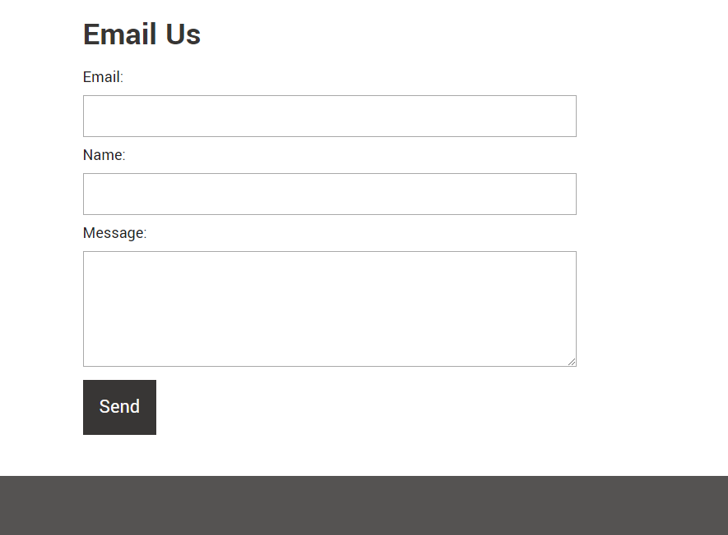

## Automatic Sticky Header

Using JavaScript, I created an automatic sticky header that will change its CSS rule to stick to the top of the page once the user has scrolled passed the object. I also decided to add some branding to the navigation in sticky mode by showing the organization’s logo.

NON-STICKY

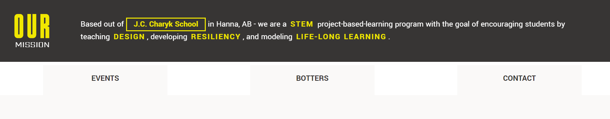

STICKY

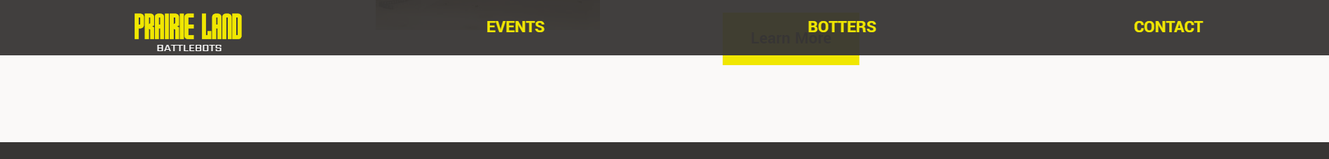

## Smooth Scrolling (If supported by the browser)

Using JavaScript, I added a simple script that uses a try – catch block to attempt to use smooth scrolling rather than jump to a specific section in a webpage. This is best shown in the Botter page. The botter page also uses this and the “Sticky Header” to display a scroll back to top button.

NORMAL

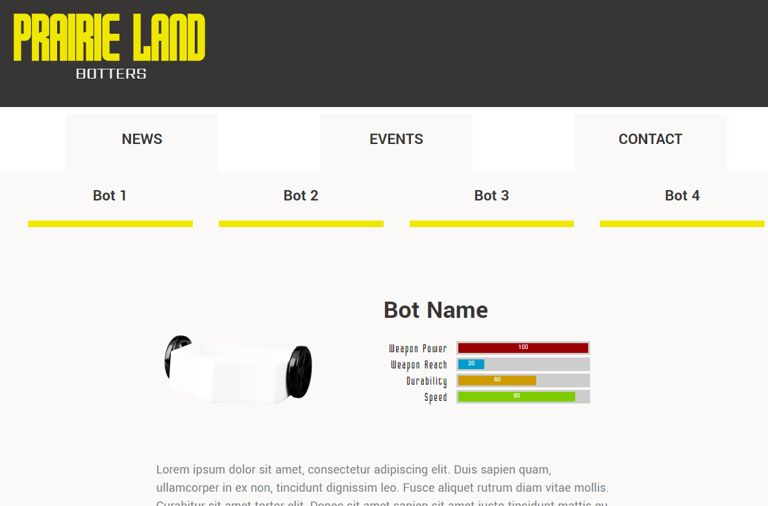

BOT 2 /w SCROLL TO TOP BUTTON

